**Verpakkingen thema:**

* Strak
* Lux
* Simpel

ze zien er vaak wat duurder uit en zien er super glad uit. Het product heeft dan vaak egale oppervlaktes

[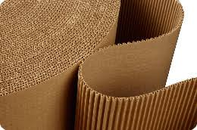](https://www.google.nl/imgres?imgurl=https%3A%2F%2Froyalbrinkman.nl%2Fcontent%2Ffiles%2Fimages%2Ffoto's%2FKarton%2520als%2520verpakkingsmateriaal.png&imgrefurl=https%3A%2F%2Froyalbrinkman.nl%2Fkennisbank-verpakking-ontwerp%2Fkarton-als-verpakkingsmateriaal&docid=JgLrqaRlLrBGfM&tbnid=iGRpVFOpyOl7cM%3A&vet=1&w=260&h=172&bih=747&biw=1536&ved=0ahUKEwilr6W9zMTeAhWKJlAKHYl2BDkQMwiQASgfMB8&iact=c&ictx=1)[](https://www.google.nl/imgres?imgurl=https%3A%2F%2Fstatic.webshopapp.com%2Fshops%2F022345%2Ffiles%2F007201715%2Fbever-nylon-waterafstotend-fluor-rood-oranje.jpg&imgrefurl=https%3A%2F%2Fwww.stoffen-online.nl%2Fbever-nylon-waterafstotend-fluor-rood-oranje.html&docid=VviTBDfwe6uIpM&tbnid=2wH3JR-lRcF3QM%3A&vet=1&w=833&h=833&bih=747&biw=1536&ved=0ahUKEwi__vezzMTeAhWCKVAKHT-YBKwQMwg4KAAwAA&iact=c&ictx=1)[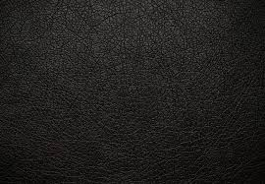](https://www.google.nl/imgres?imgurl=https%3A%2F%2Fblog.drukwerkmax.nl%2Fwp-content%2Fuploads%2F2015%2F02%2Fdrukwerkmax-kleurenreeks-zwart-header.jpg&imgrefurl=https%3A%2F%2Fblog.drukwerkmax.nl%2Fkleurenreeks-waarom-zwart-geen-kleur%2F&docid=Ej_kx6WybeE_qM&tbnid=OLQCjJ56SPrtuM%3A&vet=1&w=650&h=450&bih=747&biw=1536&ved=0ahUKEwiq4pidzMTeAhVLL1AKHc2aAncQMwhCKAMwAw&iact=c&ictx=1)

[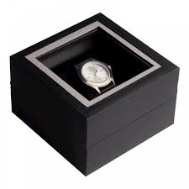](https://www.google.nl/url?sa=i&rct=j&q=&esrc=s&source=images&cd=&cad=rja&uact=8&ved=2ahUKEwiiqrWtzsTeAhWQmbQKHZEUCzAQjRx6BAgBEAU&url=https%3A%2F%2Fwww.complementair.net%2Fverpakking-van-polshorloges&psig=AOvVaw09VeebTkp7x-4GuDdJaT7V&ust=1541760075835392)[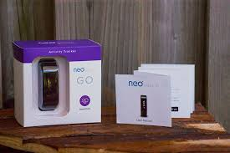](https://www.google.nl/imgres?imgurl=http%3A%2F%2Fdyanadibbets.nl%2Fwp-content%2Fuploads%2F2017%2F07%2Fneo-health-go-verpakking-manual.jpg&imgrefurl=http%3A%2F%2Fdyanadibbets.nl%2Fwork%2Fverpakkingen%2F&docid=iqLUfH0yRJhmdM&tbnid=gyqyiAoSpSOfkM%3A&vet=1&w=1026&h=683&bih=747&biw=1536&ved=0ahUKEwiPu7HwzcTeAhVObVAKHUldCrkQMwhBKAIwAg&iact=c&ictx=1)

[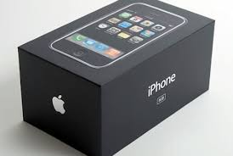](https://www.google.nl/imgres?imgurl=http%3A%2F%2Fwww.packonline.nl%2Fwp-content%2Fuploads%2F2012%2F11%2Fapple-verpakking.jpg&imgrefurl=http%3A%2F%2Fwww.packonline.nl%2Fnieuws%2Fverpakkingen-apple-in-de-toekomst-wellicht-te-gebruiken-als-oplader&docid=BoJ9e-47WAzMzM&tbnid=nKi46z8EzVfXEM%3A&vet=1&w=468&h=315&bih=747&biw=1536&ved=0ahUKEwjmj6n-zcTeAhVOYlAKHQrQDj8QMwhAKAEwAQ&iact=c&ictx=1)

[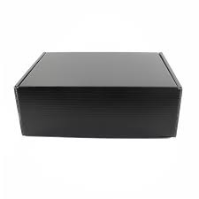](https://www.google.nl/imgres?imgurl=https%3A%2F%2Fartipack.nl%2Fwp-content%2Fuploads%2F2016%2F10%2Fverzenddozen-karton-zwart-0540.jpg&imgrefurl=https%3A%2F%2Fartipack.nl%2Fproduct%2Fxl-verzenddozen-karton-zwart%2F&docid=e9CjldsORzlFcM&tbnid=kd5UgUz5DFSE8M%3A&vet=1&w=800&h=800&bih=747&biw=1536&ved=0ahUKEwiszIfZzMTeAhVGUlAKHWctApEQMwhkKAQwBA&iact=c&ictx=1)

[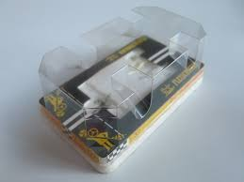](https://www.google.nl/imgres?imgurl=https%3A%2F%2Fstatic.mijnwebwinkel.nl%2Fwinkel%2Fraceparadijs%2Fimage%2Fcache%2Ffull%2F566ae08d372caec6bd78a756e462ed964fdf4d90.jpg&imgrefurl=https%3A%2F%2Fwww.fleischmannparadijs.nl%2Fa-39371934%2Foriginele-verpakkingen-auto-s%2F3225-verpakking-porsche-911-turbo%2F&docid=c8Sr8FfqT6HBfM&tbnid=D6B0EiZJnrHCSM%3A&vet=1&w=800&h=600&itg=1&bih=747&biw=1536&ved=0ahUKEwjig7b_zMTeAhWKaFAKHSJ8C7MQMwhSKBAwEA&iact=c&ictx=1)[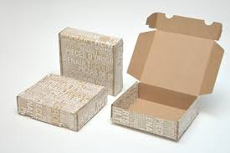](https://www.google.nl/imgres?imgurl=https%3A%2F%2Fwww.buroform.be%2Fburoform%2Fassets%2Fverpakkingen-renaultgroup.jpg&imgrefurl=https%3A%2F%2Fwww.buroform.be%2Fverpakkingen-puur-maatwerk%2F&docid=6AMmLCaT6u8DUM&tbnid=j5ATUhw-83ByjM%3A&vet=1&w=1200&h=800&bih=747&biw=1536&ved=0ahUKEwjEk_rwzMTeAhVGYVAKHUSfCysQMwg7KAYwBg&iact=c&ictx=1)