**Industrieel**

**Thema’s die vaak voorkomen bij industrieel:**

* **Stoer**
* **Ruw**
* **Robuust**

**Je ziet vaak bij industrieel dat het lijkt of het uit de fabriek komt. De materialen die vaak worden gebruikt zijn hout en metalen. de materialen zien er vaak ook onbehandeld er uit.**

[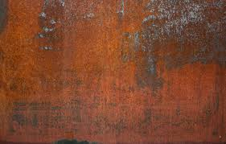](https://www.google.nl/imgres?imgurl=https%3A%2F%2Fwww.hausjournal.net%2Fwp-content%2Fuploads%2FKorrosion-Eisen.jpg&imgrefurl=https%3A%2F%2Fwww.hausjournal.net%2Fkorrosion-eisen&docid=5JE_srSdd1AZ7M&tbnid=s-CpgTHSHbs3CM%3A&vet=1&w=867&h=554&bih=747&biw=1536&ved=2ahUKEwiK5vOV9JfeAhXK-qQKHT42BtYQxiAoBXoECAEQGQ&iact=c&ictx=1)[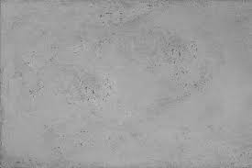](https://www.google.nl/imgres?imgurl=https%3A%2F%2Flivingconcrete.co.uk%2Fwp-content%2Fuploads%2F2017%2F06%2Fplain_rough_typhoon_60x90.jpg&imgrefurl=https%3A%2F%2Flivingconcrete.co.uk%2Fproduct%2Frough-concrete-panels-visible-pits%2F&docid=fVFsPjwjyFjkFM&tbnid=KPm36KrPsCWE-M%3A&vet=1&w=800&h=533&bih=747&biw=1536&ved=2ahUKEwj-xsay9JfeAhUE-aQKHegdDOcQxiAoBXoECAEQGQ&iact=c&ictx=1)[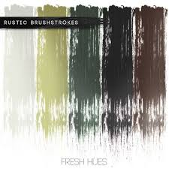](https://www.google.nl/imgres?imgurl=http%3A%2F%2Fwww.interieurinspiratie.nl%2Fwp-content%2Fuploads%2F2016%2F08%2Findustriele-woonstijl-kleur.jpg&imgrefurl=http%3A%2F%2Fwww.interieurinspiratie.nl%2Flampenkap-industrieel%2F&docid=M_qyJEegZUyiMM&tbnid=b7mGXD8DPC_ryM%3A&vet=1&w=564&h=564&bih=747&biw=1536&ved=0ahUKEwjT4bib9ZfeAhXGCuwKHensDrsQMwhbKBYwFg&iact=c&ictx=1)[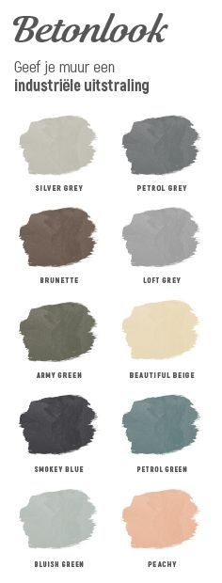](https://www.google.nl/url?sa=i&rct=j&q=&esrc=s&source=images&cd=&cad=rja&uact=8&ved=2ahUKEwiq0Ou185feAhUO_qQKHauqCQkQjRx6BAgBEAU&url=https%3A%2F%2Fwww.pinterest.com%2Fpin%2F388013324138309727%2F&psig=AOvVaw1Zs1EM9K_MVGhSYc5Xva5z&ust=1540223920803697)[](https://www.google.nl/imgres?imgurl=https%3A%2F%2Fdedonderschilderwerken.be%2Fwp-content%2Fuploads%2F2018%2F01%2FMortex-Beton-Cire-1067x600.jpg&imgrefurl=https%3A%2F%2Fdedonderschilderwerken.be%2Fnews%2Fmortex-of-beton-cire%2F&docid=Ih7aMJN372aFPM&tbnid=1dPl5Pu6XqWUKM%3A&vet=1&w=1066&h=600&bih=747&biw=1536&ved=0ahUKEwi3mvjn9JfeAhXH_KQKHbRLBToQMwiMASgrMCs&iact=c&ictx=1)[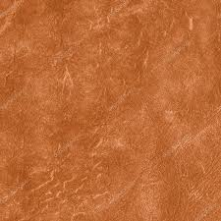](https://www.google.nl/imgres?imgurl=https%3A%2F%2Fst.depositphotos.com%2F1332421%2F4566%2Fi%2F950%2Fdepositphotos_45663685-stockafbeelding-verfrommeld-versleten-bruin-leer.jpg&imgrefurl=https%3A%2F%2Fnl.depositphotos.com%2F45663685%2Fstockafbeelding-verfrommeld-versleten-bruin-leer.html&docid=UV4pXPcrjD0CFM&tbnid=lwyXkscnNe7zVM%3A&vet=1&w=1024&h=1024&bih=747&biw=1536&ved=0ahUKEwjk66aF9ZfeAhVD6aQKHTrhBG0QMwiOASgOMA4&iact=c&ictx=1)[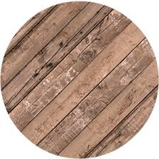](https://www.google.nl/imgres?imgurl=https%3A%2F%2Fwww.homeseeds.nl%2Fwp-content%2Fuploads%2F2015%2F12%2FIndustrieel-wonen-Materiaal-hout2.png&imgrefurl=https%3A%2F%2Fwww.homeseeds.nl%2Fwoonstijlen%2Fwoonstijl-industrieel%2F&docid=iiOxAfvq9OQ1LM&tbnid=2yVZzMgFO6NwTM%3A&vet=1&w=300&h=302&bih=747&biw=1536&ved=2ahUKEwitv-Pb85feAhUPsaQKHbNVAxUQxiAoAnoECAEQFg&iact=c&ictx=1)[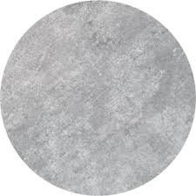](https://www.google.nl/imgres?imgurl=https%3A%2F%2Fwww.homeseeds.nl%2Fwp-content%2Fuploads%2F2015%2F12%2FIndustrieel-wonen-Materiaal-beton.png&imgrefurl=https%3A%2F%2Fwww.homeseeds.nl%2Fwoonstijlen%2Fwoonstijl-industrieel%2F&docid=iiOxAfvq9OQ1LM&tbnid=aqb8byOb4ZBVwM%3A&vet=1&w=300&h=300&bih=747&biw=1536&ved=0ahUKEwj47-XV85feAhUGsqQKHYVMABcQMwiHASg_MD8&iact=c&ictx=1)[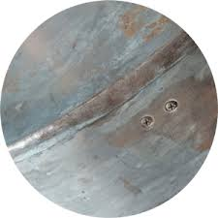](https://www.google.nl/imgres?imgurl=https%3A%2F%2Fwww.homeseeds.nl%2Fwp-content%2Fuploads%2F2015%2F12%2FIndustrieel-wonen-Materiaal-staal2.png&imgrefurl=https%3A%2F%2Fwww.homeseeds.nl%2Fwoonstijlen%2Fwoonstijl-industrieel%2F&docid=iiOxAfvq9OQ1LM&tbnid=EoMov-S6du-paM%3A&vet=1&w=300&h=300&bih=747&biw=1536&ved=2ahUKEwitv-Pb85feAhUPsaQKHbNVAxUQxiAoAXoECAEQFQ&iact=c&ictx=1)[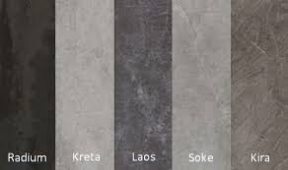](https://www.google.nl/imgres?imgurl=https%3A%2F%2Fwww.uw-woonmagazine.nl%2Fuploads%2Fproductinbeeld%2Fbig%2Farte-keukenbladen-dekton-industriyle-natuur-beton-kleuren-811994.jpg&imgrefurl=https%3A%2F%2Fwww.uw-keuken.nl%2Fproduct-arte-keukenbladen-dekton-industriele-natuur-beton-kleuren%2F&docid=vMX4z8CuU0PW5M&tbnid=lZ0zlmvNV6SbYM%3A&vet=1&w=338&h=200&bih=747&biw=1536&ved=0ahUKEwinlL-u85feAhVSM-wKHcTLBEEQMwhrKCMwIw&iact=c&ictx=1)**[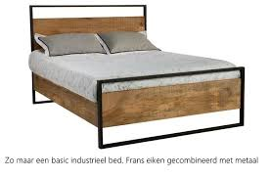](https://www.google.nl/imgres?imgurl=http%3A%2F%2Fwww.alleseiken.nl%2Fupload%2Fbedden%2Fbed_metaal2.jpg&imgrefurl=http%3A%2F%2Fwww.alleseiken.nl%2Findustriele-bedden.htm&docid=aajQiXcnVMmbzM&tbnid=NSeglXq59nIYeM%3A&vet=1&w=700&h=459&bih=747&biw=1536&ved=0ahUKEwjflZP98pfeAhVQ_qQKHXFeBRoQMwiQASgLMAs&iact=c&ictx=1)**[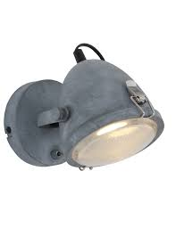](https://www.google.nl/imgres?imgurl=https%3A%2F%2Fwww.directlampen.nl%2Fwp-content%2Fuploads%2F2018%2F01%2FStoere-wandlamp-sfeervolle-uitstraling.jpg&imgrefurl=https%3A%2F%2Fwww.directlampen.nl%2Findustriele-wandlamp-lumidem-paco-grijs%2F&docid=Gy3cZcqymAGU-M&tbnid=kvXbeoVmF4DaaM%3A&vet=1&w=770&h=1000&bih=747&biw=1536&ved=0ahUKEwj8tpWS8ZfeAhUBDOwKHQblDxcQMwimASgrMCs&iact=c&ictx=1)[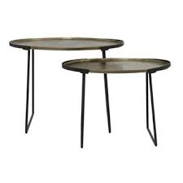](https://www.google.nl/imgres?imgurl=https%3A%2F%2Fmb.fcdn.nl%2Fsquare340%2F1213262%2Fbijzettafel-roja-ruw-antiek-brons-mat-zwart-set-van-2.jpg&imgrefurl=https%3A%2F%2Fwww.fonq.nl%2Fproduct%2Fbijzettafel-roja-ruw-antiek-brons-mat-zwart-set-van-2%2F270089%2F&docid=hZsauceBGTRAlM&tbnid=LlSMEKfetxKziM%3A&vet=1&w=340&h=340&itg=1&bih=747&biw=1536&ved=2ahUKEwjQ_oDy8ZfeAhVGDOwKHatrASM4ZBAzKBowGnoECAEQHA&iact=c&ictx=1)[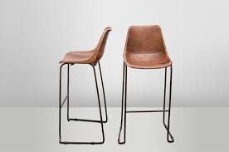](https://www.google.nl/imgres?imgurl=http%3A%2F%2Fstatic.webshopapp.com%2Fshops%2F064323%2Ffiles%2F024365531%2Fbarstool-vintage-brown.jpg&imgrefurl=http%3A%2F%2Fwww.nupuurengroen.nl%2Fen%2Fbarstool-vintage-brown.html&docid=MlWCWBEsTInsqM&tbnid=z7fbxuM_fT6LcM%3A&vet=1&w=707&h=468&bih=747&biw=1536&ved=2ahUKEwiSqeby8ZfeAhVG66QKHb8bDyIQxiAoBHoECAEQGA&iact=c&ictx=1)**[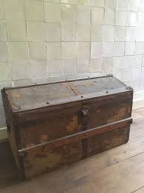](https://www.google.nl/imgres?imgurl=https%3A%2F%2Fwww.koezoe.nl%2Fwp-content%2Fuploads%2F2018%2F08%2F19895.jpg&imgrefurl=https%3A%2F%2Fwww.koezoe.nl%2Fproduct%2Fstoere-oude-houten-kist%2F&docid=n96AXgpBh4CTQM&tbnid=8dDlxEVJQHwQIM%3A&vet=1&w=600&h=800&itg=1&bih=747&biw=1536&ved=0ahUKEwiH_qf-8JfeAhVJ2qQKHXiJAsoQMwg9KAcwBw&iact=c&ictx=1)[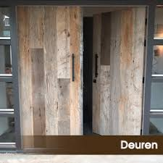](https://www.google.nl/imgres?imgurl=https%3A%2F%2Fwww.robuustmaatwerk.nl%2Fwp-content%2Fuploads%2Frobuust-producten-deuren-1.jpg&imgrefurl=https%3A%2F%2Fwww.robuustmaatwerk.nl%2Fmaatwerk%2Frobuust-producten-deuren-2%2F&docid=nMJWazN2wxw7wM&tbnid=usC0ORVxfG9m5M%3A&vet=1&w=259&h=259&bih=747&biw=1536&ved=0ahUKEwiTp9vK8JfeAhUCDuwKHa4ACRoQMwguKAAwAA&iact=c&ictx=1)**[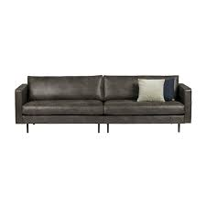](https://www.google.nl/imgres?imgurl=https%3A%2F%2Fhomestock.nl%2Fwp-content%2Fuploads%2F2016%2F12%2FHOME-STOCK-BE-PURE-SMART-BANK-RODEO-BANK-CLASSIC-3-ZITS-ZWART-LEER-RECYCLE-LEER-STOERE-BANK-2.jpg&imgrefurl=https%3A%2F%2Fhomestock.nl%2Fshop%2Fmeubels%2Fbanken%2Frecycle-leren-bank-stoer-classic%2F&docid=_6xjKVIWqCJnsM&tbnid=03Tszfv6HbfY9M%3A&vet=1&w=1000&h=1000&bih=747&biw=1536&ved=0ahUKEwj8tpWS8ZfeAhUBDOwKHQblDxcQMwiaASgfMB8&iact=c&ictx=1)[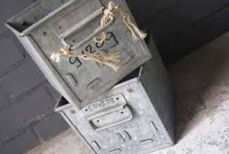](https://www.google.nl/imgres?imgurl=http%3A%2F%2Fmusthaveblog.nl%2Fwp-content%2Fuploads%2F2017%2F09%2FQwuote-6-345x231.jpg&imgrefurl=http%3A%2F%2Fmusthaveblog.nl%2Fq-wuote%2F&docid=RX7MqYYOs7K9aM&tbnid=bfheK51H3GZz8M%3A&vet=1&w=345&h=231&bih=747&biw=1536&ved=2ahUKEwiTvanJ8ZfeAhVP3aQKHQblD-M4ZBAzKAcwB3oECAEQCA&iact=c&ictx=1)