[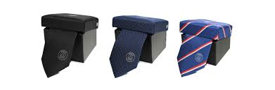](https://www.google.nl/imgres?imgurl=http%3A%2F%2Fwww.tiesinternational.com%2Fwp-content%2Fuploads%2F2015%2F11%2Fluxe-geschenkverpakking.jpg&imgrefurl=http%3A%2F%2Fwww.tiesinternational.com%2Fproduct-category%2Fverpakkingen%2F&docid=9C7XfFti9t2P7M&tbnid=I4H07eb5ailavM%3A&vet=1&w=2178&h=721&bih=747&biw=1536&ved=2ahUKEwiJofWwyMbdAhWMyKQKHbeHCQQ4yAEQMygLMAt6BAgBEAw&iact=c&ictx=1)[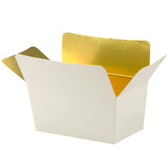](https://www.google.nl/imgres?imgurl=http%3A%2F%2Fwww.biopack.be%2FDocs%2FImages%2FGroups%2F1%2Fwebshop_praline_wit_goud.jpg&imgrefurl=http%3A%2F%2Fwww.biopack.be%2FVoeding___Drank_Verpakking%2F13-331%2FPralinedozen_Ballotins.aspx%3Fitem%3DVoeding___Drank_Verpakking-Pralinedozen_Ballotins&docid=6qsYUk9tirE2JM&tbnid=gpS-B40ytjEGkM%3A&vet=1&w=500&h=500&bih=747&biw=1536&ved=2ahUKEwj6jaKXyMbdAhXNjqQKHfTGB304ZBAzKDkwOXoECAEQOg&iact=c&ictx=1)[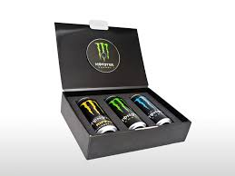](https://www.google.nl/imgres?imgurl=http%3A%2F%2Fwww.vinkedisplay.com%2Fimages%2Fproducten%2Fcoca-cola-verpakking-monster-egolf-schuim-3-blikken.jpg&imgrefurl=http%3A%2F%2Fwww.vinkedisplay.com%2Fproducten%2Fdisplays%2Fverpakkingen-mailingen&docid=p5hvcvp8KukZfM&tbnid=4Sh5hoOIHKAGhM%3A&vet=1&w=960&h=720&bih=747&biw=1536&ved=0ahUKEwiwu-eDyMbdAhUQ6qQKHQxJCL0QMwiXAShVMFU&iact=c&ictx=1)[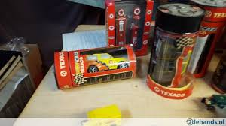](https://www.google.nl/imgres?imgurl=https%3A%2F%2Fimg.tweedehands.nl%2Ff%2Fnormal%2F439022998_6-nieuwe-speelgoed-auto-s-in-originele-verpakking.jpg&imgrefurl=https%3A%2F%2Fwww.tweedehands.nl%2Fspeelgoed-spelletjes%2Fspeelgoed%2Fautootjes%2Fnieuwe-speelgoed-auto-s-in-originele-439022998.html&docid=3GZzEx0kQdbyhM&tbnid=_JZGdCuzseghuM%3A&vet=1&w=728&h=409&itg=1&bih=747&biw=1536&ved=0ahUKEwjiqtm0x8bdAhXNGewKHQ1JA2cQMwg8KAUwBQ&iact=c&ictx=1)[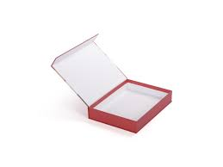](https://www.google.nl/imgres?imgurl=https%3A%2F%2Fpresentationproducts.nl%2Fwp-content%2Fuploads%2F2017%2F10%2Fluxe-doos-met-magneetsluiting-2.jpg&imgrefurl=https%3A%2F%2Fpresentationproducts.nl%2Fportfolio%2Fklepdoos-met-magneetsluiting%2F&docid=sYf2BxAuAzZVmM&tbnid=3LVBXyhnW-jvZM%3A&vet=1&w=2048&h=1536&bih=747&biw=1536&ved=2ahUKEwjO8K--ysbdAhUQ6qQKHQxJCL0QxiAoBHoECAEQGA&iact=c&ictx=1)[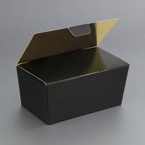](https://www.google.nl/imgres?imgurl=http%3A%2F%2Fwww.belofe.com%2FWebRoot%2FStoreLNL%2FShops%2F17945871%2F5971%2FF21F%2FD44A%2FE95C%2F90E8%2FC0A8%2F29BF%2FBF67%2Fbal_mzt_m.jpg&imgrefurl=http%3A%2F%2Fwww.belofe.com%2FDoosjes%2FBallotin&docid=UOlNhbggxWdhKM&tbnid=l19-VadXtRP6TM%3A&vet=1&w=200&h=200&bih=747&biw=1536&ved=2ahUKEwj6jaKXyMbdAhXNjqQKHfTGB304ZBAzKCowKnoECAEQKw&iact=c&ictx=1)[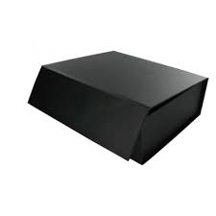](https://www.google.nl/imgres?imgurl=https%3A%2F%2Fwww.rawa.nl%2Fmedia%2Fcatalog%2Fproduct%2Fcache%2F19%2Fimage%2F500x500%2F9df78eab33525d08d6e5fb8d27136e95%2Fb%2Fr%2Fbronzen_beelden_gkunen59.jpg&imgrefurl=https%3A%2F%2Fwww.rawa.nl%2Fpersoonlijk%2Fgraveren%2Fluxe-geschenkdoos.html&docid=3GjzuRgbr3GZuM&tbnid=NH2cIyIn5NZvrM%3A&vet=1&w=500&h=500&bih=747&biw=1536&ved=0ahUKEwiwu-eDyMbdAhUQ6qQKHQxJCL0QMwiKAShIMEg&iact=c&ictx=1)[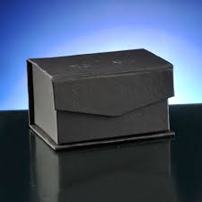](https://www.google.nl/imgres?imgurl=http%3A%2F%2Fwww.custom-company.nl%2Fimages%2Fproductimages%2Fbig%2Fverpakking_doos_karton_luxe_rechthoek.jpg&imgrefurl=http%3A%2F%2Fwww.custom-company.nl%2Findustriele-productie%2Fverpakking%2Fluxe-verpakking-8x8x12cm&docid=-goqp1TqvXQ4MM&tbnid=BMa55euLyFSf_M%3A&vet=1&w=510&h=510&bih=747&biw=1536&ved=2ahUKEwjStYeFysbdAhUFMewKHVQUDjUQxiAoAXoECAEQFQ&iact=c&ictx=1)[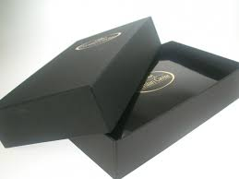](https://www.google.nl/imgres?imgurl=http%3A%2F%2Fwww.luxeverpakkingen.nl%2Finclude%2Fnl%2Fproducts%2F58%2Fresize%5B800x600%5D%2F301.jpg&imgrefurl=http%3A%2F%2Fwww.luxeverpakkingen.nl%2Fproducten%2Fcategorie-39%2F58%2Fcaviar-verpakking&docid=gCVNo_lFqVGckM&tbnid=jQKVCV3AOKt8YM%3A&vet=1&w=800&h=600&bih=747&biw=1536&ved=0ahUKEwiwu-eDyMbdAhUQ6qQKHQxJCL0QMwg4KAEwAQ&iact=c&ictx=1)[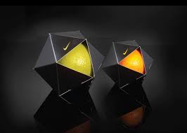](https://www.google.nl/imgres?imgurl=http%3A%2F%2Fwww.want.nl%2Fwp-content%2Fuploads%2F2014%2F04%2Fwant-verpakkingen1.png&imgrefurl=https%3A%2F%2Fwww.want.nl%2Fwat-als-merken-als-apple-en-chanel-luxe-eten-produceerden%2F&docid=RvTRfOGO5sCRxM&tbnid=rZLOUy7Ug5jPjM%3A&vet=1&w=700&h=500&bih=747&biw=1536&ved=0ahUKEwiwu-eDyMbdAhUQ6qQKHQxJCL0QMwh3KDYwNg&iact=c&ictx=1)[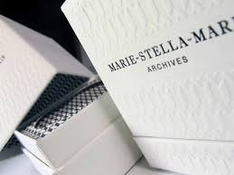](https://www.google.nl/imgres?imgurl=https%3A%2F%2Fwww.vrijdag.nl%2Fresources%2Fimages%2Fproducten%2Fc_box_marie_stella_maris_1_1.jpg&imgrefurl=https%3A%2F%2Fwww.vrijdag.nl%2Fproducten%2Fnatlijm_etiketten%2Fdetails%2Fvouwkartonnage&docid=znjoYVQwnPPv2M&tbnid=vyRxJ_LpyCn1wM%3A&vet=1&w=1280&h=960&bih=747&biw=1536&ved=2ahUKEwj6jaKXyMbdAhXNjqQKHfTGB304ZBAzKDgwOHoECAEQOQ&iact=c&ictx=1)[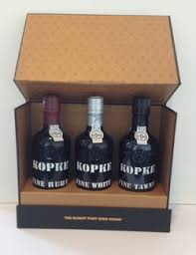](https://www.google.nl/imgres?imgurl=http%3A%2F%2Fwww.wijnhandelvanouwerkerk.nl%2Fartikelen%2F73c883105a20588b2d6147736a190ae50.jpg&imgrefurl=http%3A%2F%2Fwww.wijnhandelvanouwerkerk.nl%2Fproduct-specialiteiten%2Fkopke_port%2Fkopke_port%2Fspeciale_verpakkingen_port_%2Fluxe_zwarte_doos_met_3_halve_flesjes_ruby_tawny_en_white_port%2F&docid=szkR5iJkHxKeqM&tbnid=IUeoc4HUVdlcOM%3A&vet=1&w=250&h=326&itg=1&bih=747&biw=1536&ved=2ahUKEwiJofWwyMbdAhWMyKQKHbeHCQQ4yAEQMyg8MDx6BAgBED4&iact=c&ictx=1)